

**5th Week Report**

**OJO Members:**

Abdullah Aslam: ***phone:*** *+90 (538) 050 37 64* ***email:*** *ama.abdullah90@gmail.com*

Anar Abdullayev: ***phone:*** *+90 (553) 924 96 43* ***email:*** *abdullayev.1995@gmail.com*

Bulut Ulukapı:  ***phone:*** *+90 (555) 367 26 16*  ***email:*** *ulukapi.bulut@metu.edu.tr*

Syed Saad Saif: ***phone:*** *+90 (546) 781 99 50* ***email:*** *saad.saif@metu.edu.tr*

Umut Can Serçe:***phone*:** *+90 (506) 997 99 88* ***email:*** *serce.umut@metu.edu.tr*

This week, we started to work on our mock-up robot. For this purpose, we used a shoe box. We cut the shoe box to make it compatible with our requirements. We mounted a rope in the front of the robot. Then, created a hole, which is 10 cm above the ground, to mount the power infrared LED that is used as a visibility marker. After that, we designed a circuit to drive this LED and placed it inside the box. At last, we placed a battery inside the box and supplied voltage from it to the circuit. The mock-up robot can be seen in Figure 1.

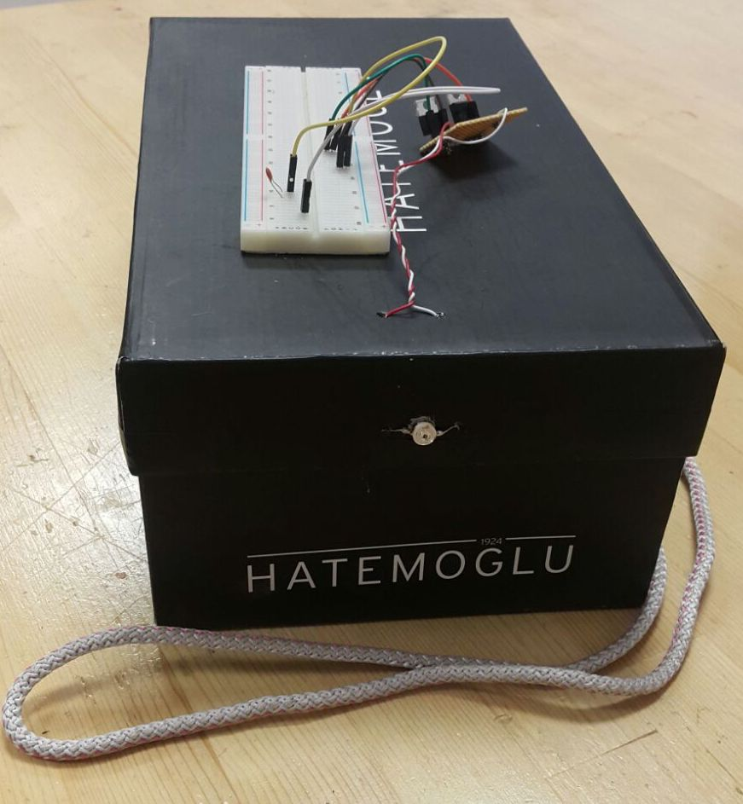

**Figure 1:** A photo of the mock-up robot

After the implementation of the mock-up, we switched on the visibility marker and checked the response of our robot. After the observation, the code uploaded to the microcontroller is slightly updated. Then, we made a test demonstration with the mock-up. The performance was quite successful. The robot managed to achieve to protect the minimum distance using the infrared distance sensor. It also achieved the following task using the infrared sensors on front sides. The maneuvers for turning after the direction of the mock-up robot is changed were also successful.